1. Basic Knowledge
2. 3D coordinate system and Math transformation

A PDF document is shared in the same folder for this.

1. Cesiumjs and its practice

* Cesiumjs Source code:

<https://github.com/CesiumGS/cesium>

* Cesiumjs document:

Quick Start Guide: <https://github.com/CesiumGS/cesium/issues/5207>

Cesium API details: <https://cesium.com/learn/cesiumjs/ref-doc/>

* Cesiumjs Practice:

<https://sandcastle.cesium.com/>

1. Algorithm and data structure, and basic Javascript/Typescript framework

* Basic algorithm and data structure knowledge for computation for large amount of point set.
* Mainly ReactJS frontend framework

Don’t share any details from the practical projects section with anyone. Or you ruin my project. Just study, learn and practice.

1. Practical Projects
2. AUS Library project

* Project name: @aus-platform/cesium
* Project type: Library
* Project functional description:

CRUD(create, read, update, delete) action for GIS primitives in Cesium canvas space,

Place/Update 3D tiles and multiple operations with it,

Drawing Tools for GIS primitives,

Camera control and primitive transformation,

1. AUS Front-end project

* Project name: gis-app
* Project type: Front-end built with reactjs and cesiumjs
* Project functional description:

It’s a project to test AUS Library project mentioned in 1).

It’s using @aus-platform/cesium library installed by using command “npm install @aus-platform/cesium”. It has rough UI like below, but it represents the results testing the library.

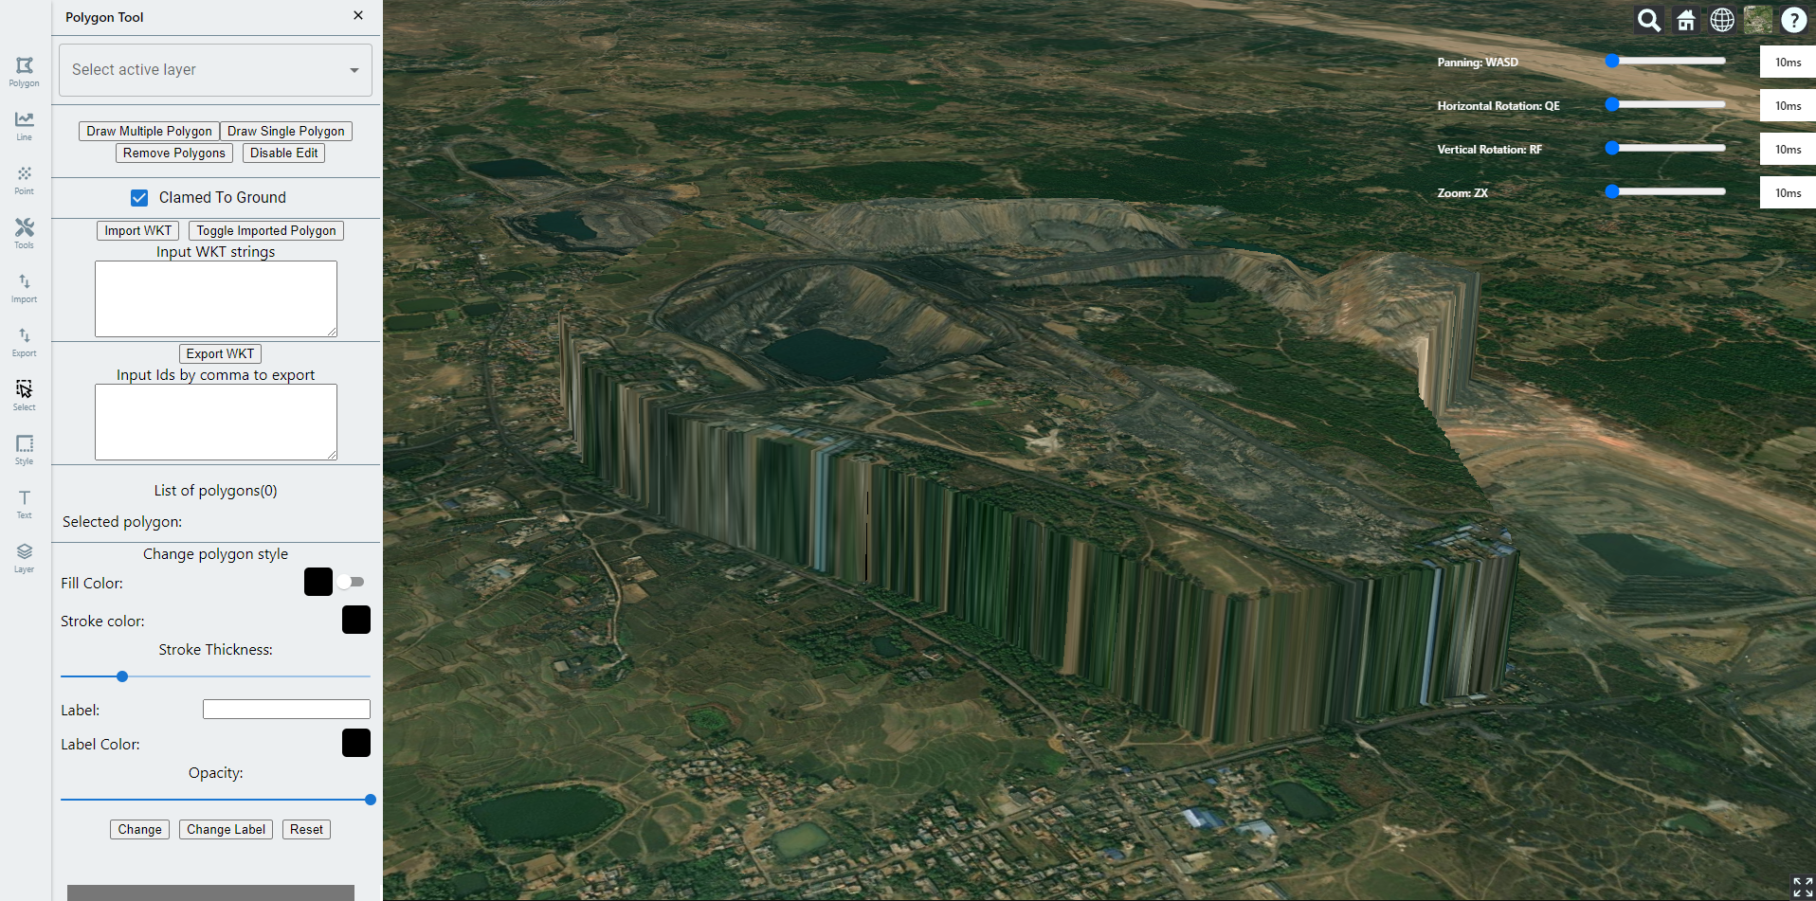

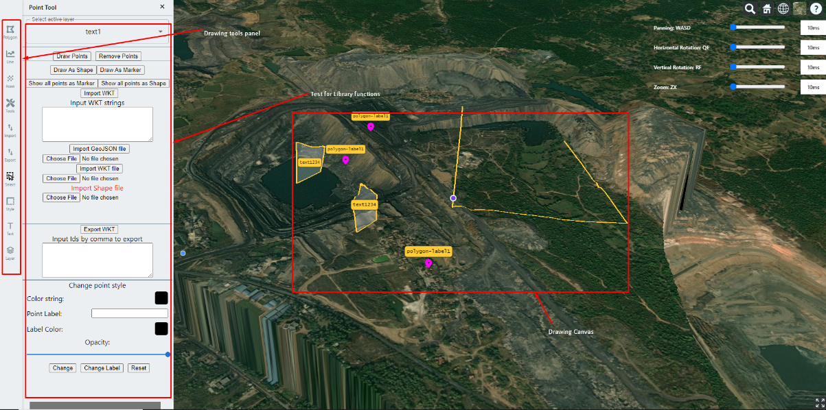

* After implementation the library functions, it can be integrated this front-end and could see it works or not.

1. Simple test on Sand castle

* Open sandcastle page on chrome browser (following url).

<https://sandcastle.cesium.com/>

* Place red sphere primitive or entity on the globe and draw bounding box.

1. Practical test

* Download 2 source codes and run gis-app project.
* The most importance thing is that it’s react based project and @aus-platform/cesium library should be integrated. The instruction is following:

Step 1: Extract @aus-platform/cesium project.

Step 2: Edit line 6 in package.json file from gis-app folder as following.

"@aus-platform/cesium": " PATH_TO_@aus-platform/cesium_FOLDER ",

Step 3: Run “npm install” in gis-app folder.

Step 4: Run “npm start” in gis-app folder.

* Implement point dragging function in Point drawing tool.

The explanation of this function is shown in the video file “point-dragging.avi” in the same folder.

Need to be implemented this in Point Tool menu.

